**TECHNOLOGIES AND SOFTWARE USED:**

Restaurant (Zonions) Application

|  |  |
| --- | --- |
| **Technologies** | **Software** |
| Spring Boot(Middle Functionality) - | Spring Tool Suite(4.8.0) |
| Angular (11.03)(Front End) - | Visual Studio Code(1.52.0) |
| MySQL(Back End) - | MySQL Workbench(8.0) |
|  | Postman |

**Schedule of work**

|  |  |
| --- | --- |
| **Date** | **Work** |
|  |  |
| 11th Dec 2020 | Understood the assignment and technical requirements |
|  |  |
| 12th Dec 2020 | Start for developing Spring Boot Rest API According to Structure of Application |
|  |  |
| 13th Dec 2020 | Working on one by one API and Accordingly check on POSTMAN |
|  |  |
| 14th Dec 2020 | Started for working on UI |
|  |  |
| 15th Dec 2020 | UI Development was under working |
|  |  |
| 16th Dec 2020 | Adding some extra validations and checking different Test cases |

WORKING OF APPLICATION IN SHORT

-Backend Working

* First checking the server in spring tool suite as this is the entry point to Spring Boot application and runs embedded tomcat.
* Creating the rest API (CREATE, UPDATE, DELETE, DISPLAY, UPLOAD FILE, DISPLAY FILE) in controller with the help of repository and service.

1. CREATE API- For storing the restaurant in database.
2. UPDATE API- For updating the fields of restaurant class.
3. DELETE API- For delete specified restaurant from database.
4. DISPLAY API- Showing all the added restaurant and its specific information.
5. UPLOAD FILE- For adding the image of menu for that specified restaurant.
6. DISPLAY FILE- For showing the added menu.

* Then registering a CORS bean in controller to allow only the domains which we would like to allow access to our resources, in this case its angular client running at localhost:4200

-Frontend Working

- Here building our application front end using angular 11.03, now we need 5 components (CREATE, DETAILS, DISPLAY ALL, HOME, UPDATE, LOGIN)

1. Create Component- For showing the restaurant registration form with some validations for adding that restaurant in database by getting URL mapped in restaurant service and model restaurant class.
2. Update Component- For showing the restaurant update form with some validations for updating the fields of restaurant and adding menu for that restaurant.
3. Home Component- For showing the default home page and list of active restaurants.
4. Display Component- Showing all the added restaurant and its specific information.
5. Detail Component- For showing some detail information related to specific restaurant.
6. Admin Login Component- login form with some validations.

WORKING OF APPLICATION IN DETAIL

1- HOMEPAGE

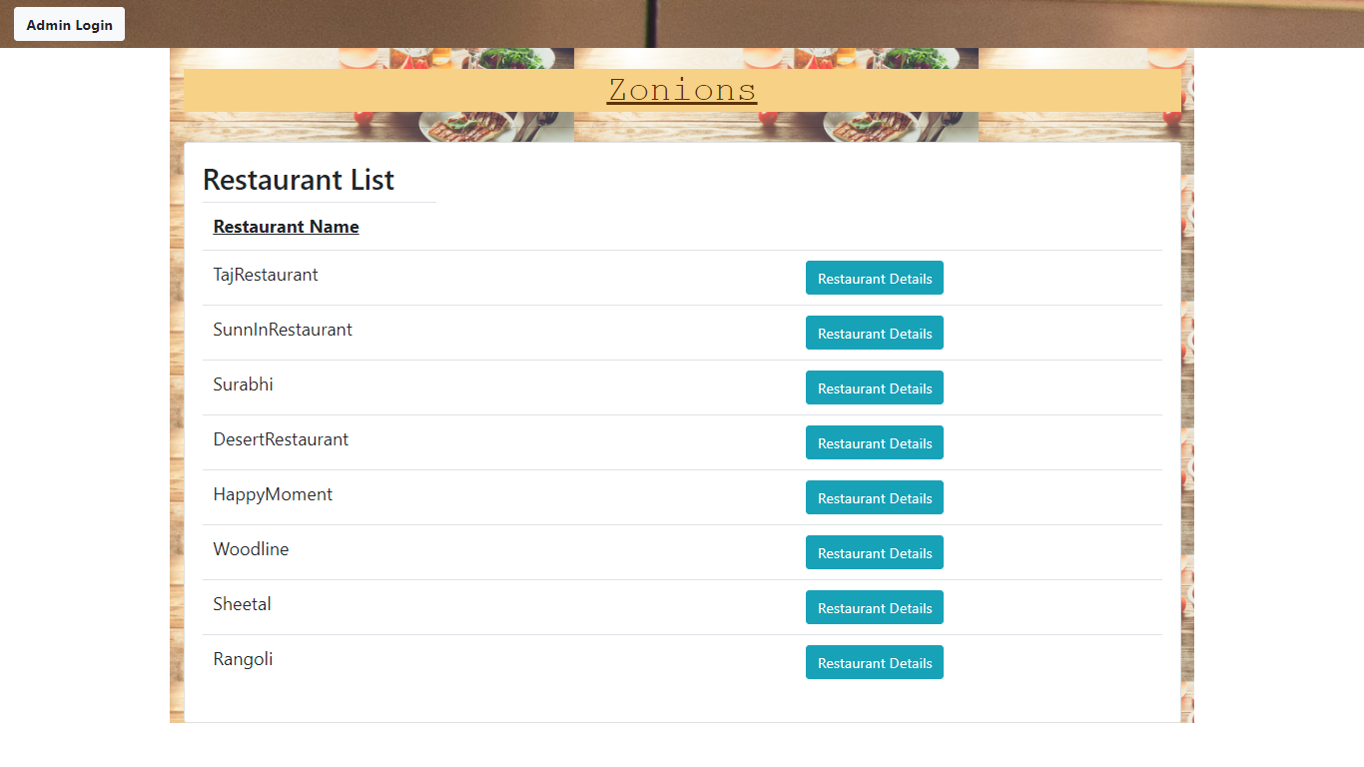

1. **On these Homepage it will display the list of all the active restaurants and one button for getting the details of that specified restaurant for end user. After click on that button user will able to see all details of that restaurant along with Menu. For that first of all admin can add these restaurant along with some details therefore admin can login first then perform next operations.**

2- ADMIN LOGIN PAGE

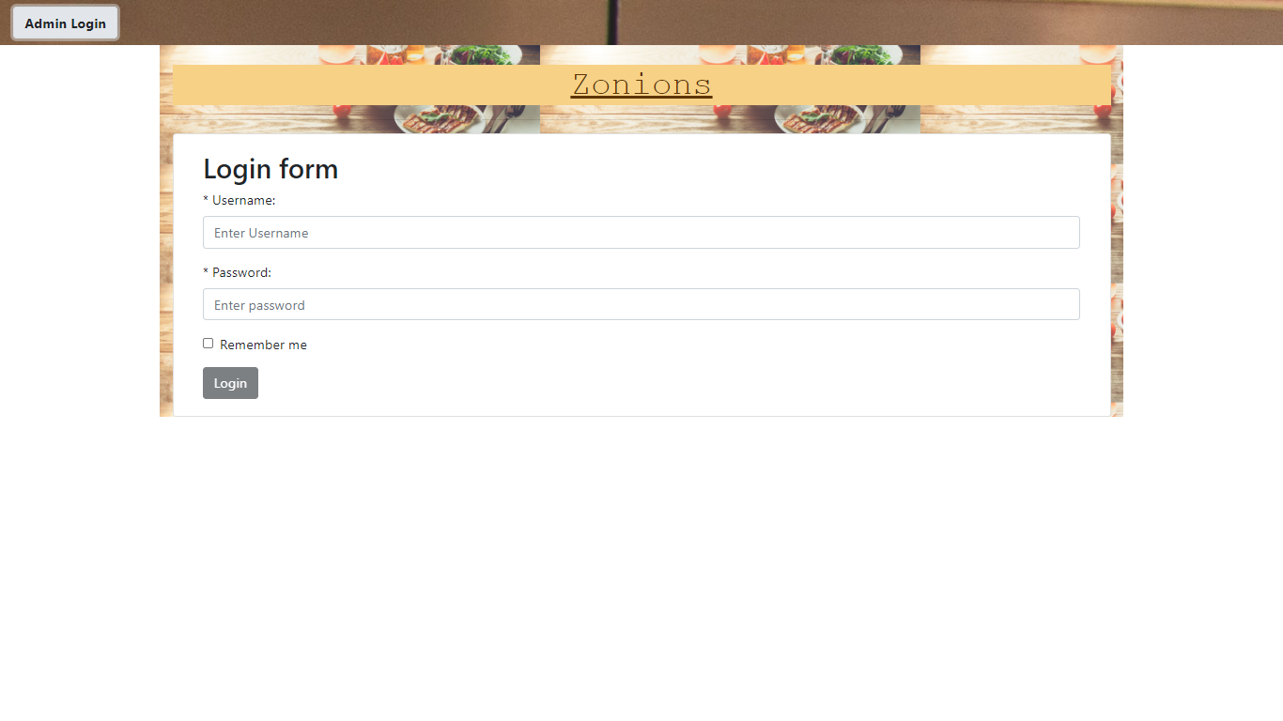

1. **Now these is admin login form where only authorised admin can able to login and perform further operations such as create ,update, delete and showing whatever restaurants added before. After successful login next functionality shown as below.**

3-ADMIN DASHBOARD (ALL RESTAURANT LIST)

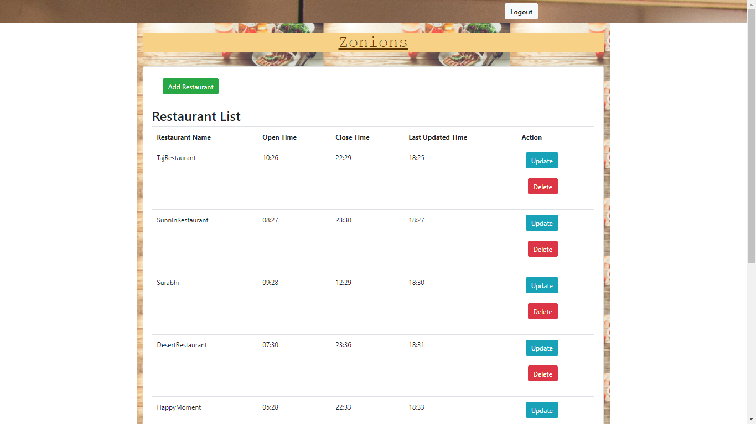

1. **Now here these is admin dashboard OR Restaurant Management Page where admin can able to add restaurants by click on that ADD RESTAURANT Button then for updating and deleting the restaurant separate UPDATE and DELETE Buttons are provided here after successfully creating and updating the restaurants here it will the show the all restaurant list on same page. Then if admin click on ADD RESTAURANT next page is open.**

4-CREATE RESTAURANT

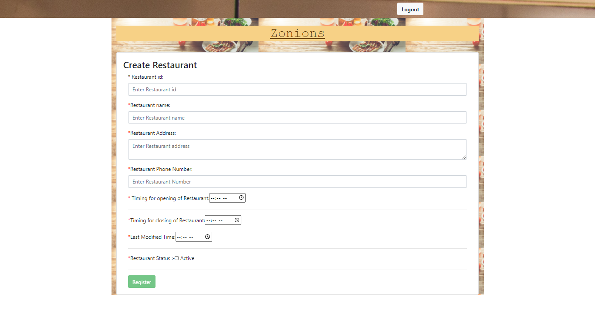

1. **Here these is restaurant registration form where admin can able to ADD restaurant after complete these type of validations or conditions such as Name (Mandatory and should not contain special characters, only alphabets and numbers are allowed), Phone (Mandatory should accept 10 digit input and first digit should be either 7, 8 or 9) etc. After successfully creating restaurant then automatically added restaurants comes on page and then if admin click on UPDATE Button then next form will open.**

5-UPDATE RESTAURANT

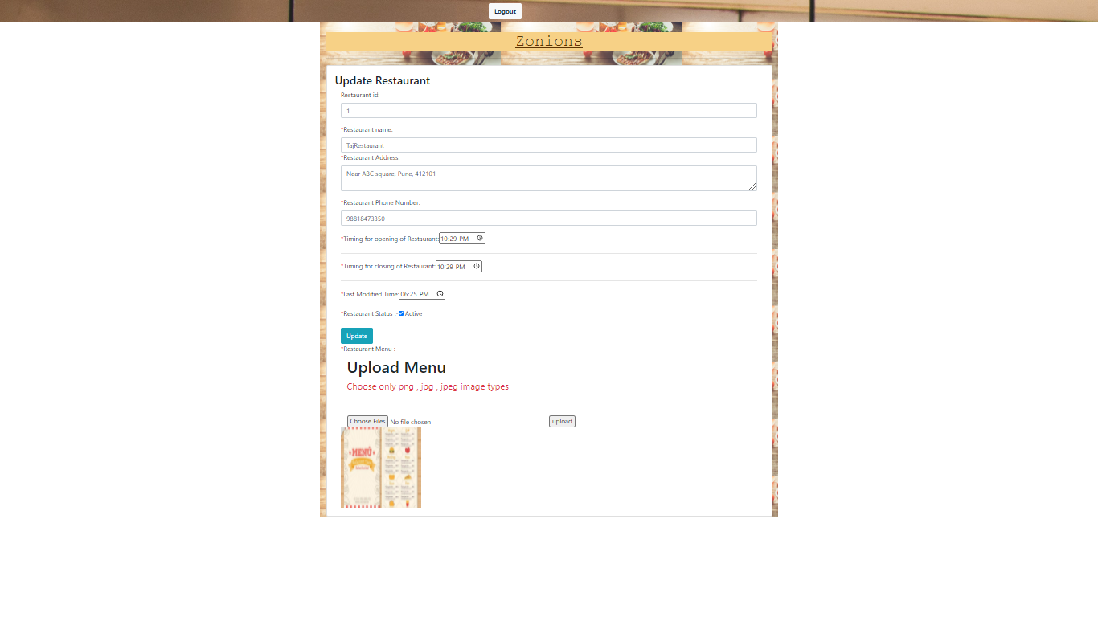

1. **These is restaurant update form. Where again whatever the validations or Conditions were added while creating the restaurant that all validations are also applied here for admin for updating the restaurant. One thing is here now admin can able to add/upload the menu (if first time admin update that restaurant) then it can able to update that menu anytime whenever updating the restaurant.**

6-RESTAURANT DETAILS

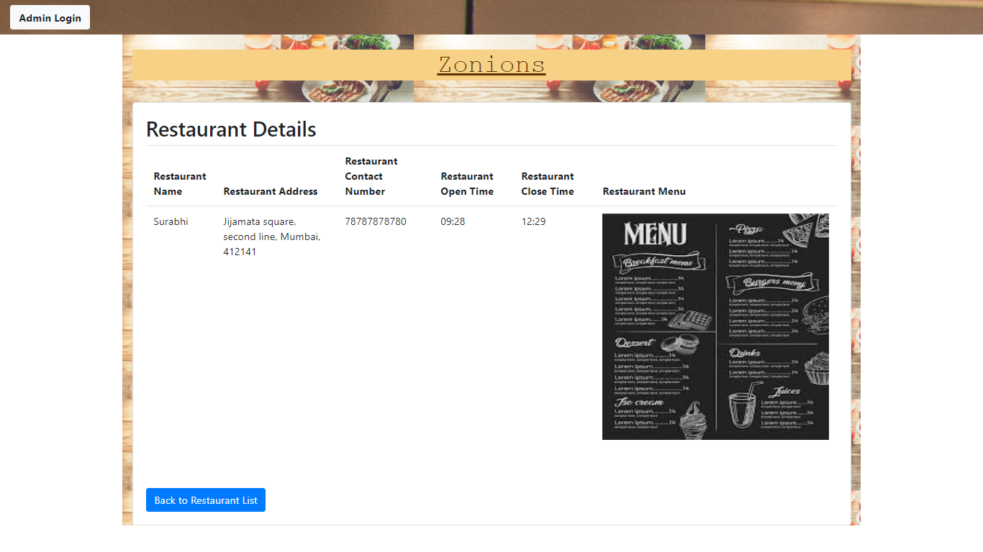

1. **After successfully adding the restaurant by admin, here end user can able to see the details of that restaurant along with menu. Whenever an admin update that restaurant details these changes are automatically reflect here (It means restaurant OPENTIME/CLOSETIME/MENU, etc.)**